Press release

Date: June 20, 2005
Contact: Innova Market Insights
Tel: (+31) 26 319 0650
E-mail: contact@innovami.com

Innova to WOW visitors to this year’s ift meeting
with new flavors and concepts.
To taste the future visit TASTE THE TREND
The annual meeting of The Institute of Food Technologists is the biggest gathering of professionals in this field in the world. Food professionals flock to the venue to see new products and taste new flavors. Of course it is also the international venue to look for new ingredients and concepts. This year’s IFT meeting will be held July 16-20 at the Ernest N. Morial Convention Center in New Orleans, Louisiana.
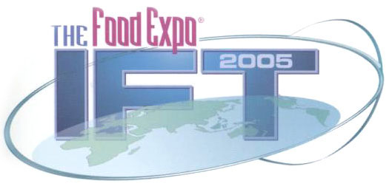
At this year’s event, new products information supplier, Innova will be joining with the Institute of Food Technologists to present Taste The Trend in a spacious pavilion, where visitors will be able to discover the trends of the future. As well as showcasing hundreds of trend setting prepared foods from around the world, Innova will also display nine entirely new beverage concepts of its own. Along with the complete packaging and design concept you will also be able to taste nine exciting new flavors when you visit the Innova Taste the Trend pavilion.
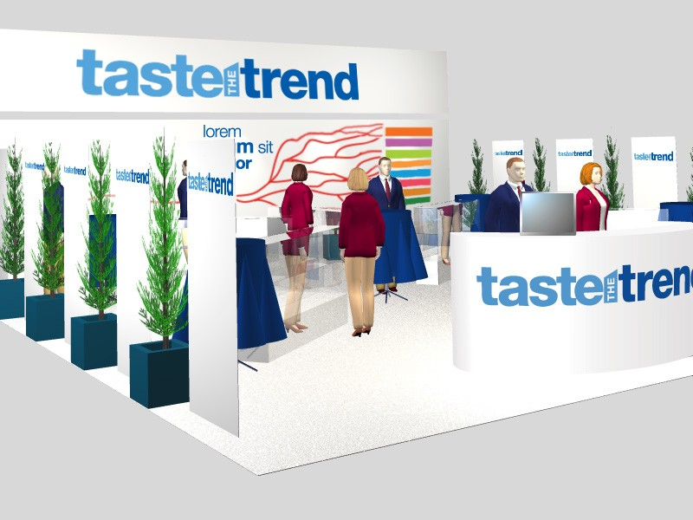
“At this year’s IFT meeting we aim to wow your taste buds. Visitors to this event want to discover new ideas and inspiration and that is what we will provide,” that’s the promise of Innova’s Patrick Mannion, who will be leading the team of analysts on the stand.
In one compelling location, Innova will show really exciting concepts for the future so you can “taste the trend.” Innova’s database can be used to see what is happening around the world, but Innova also wants to point the way forward at the IFT, through illustrations and concepts.
Innova has designed a series of displays, demonstrating an extensive array of products, along with opportunities for tasting and expert consultation for the IFT, in order to ensure that the trends illustrate what is happening now and what will happen.
“Innova’s goal is to present new and exciting flavor concepts to illustrate emerging trends,” says LuAnn Williams, lead analyst with Innova. “Along with that, visitors will receive vital consumer insights, as well as, marketing and positioning intelligence,” she notes.
Among the extensive list of feature presentations on display for you are:
• Food for seniors • Healthy options
• Euro Chef’s ideas • Drinks of the future
“We have designed the stand so the visitors can come at any time and see the features. They can dash off to meetings and come back and pick up where they left off,” says Robin Wyers, one of the editors at Innova. “We have lots of information that visitors can really benefit from and use to stimulate discussions on new products and innovation when they return to their own companies,” he explains.
At Innova’s international presentation of new products, visitors will be able to explore new ways about thinking about food and beverage trends. Innova will display examples on how leading companies around the world have capitalized on these trends. The presentation will without a doubt provide a unique learning experience.
“I am glad that we have this opportunity to show what we can do to visitors who don’t already know us. It is great to be able to demonstrate what our firm is capable of in this environment,” says Albert Starink, Marketing Manager at Innova. “Taste The Trend is the most exciting project I have been associated with over the years. I know the visitors will love it. It really is that good,” he concluded.
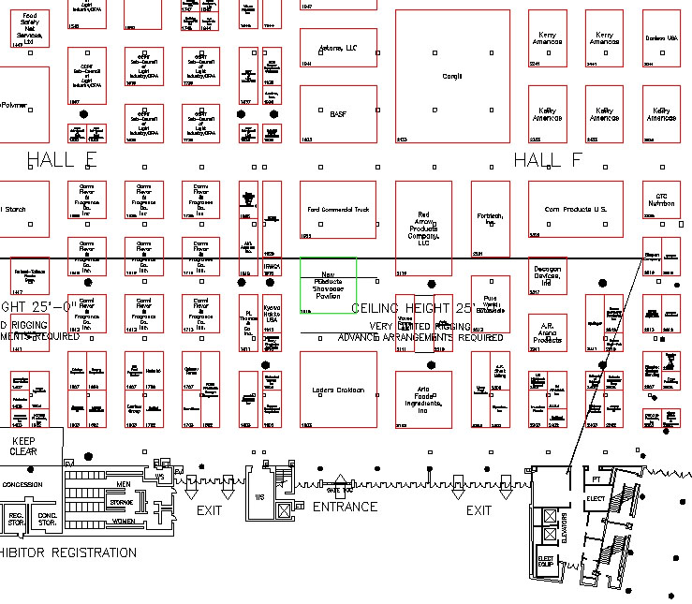
Sunday, July 17: 11:00 a.m. - 5:30 p.m.
Monday, July 18: 11:00 a.m. - 5:30 p.m.
Tuesday, July 17: 11:00 a.m. - 5:30 p.m.

Innova’s 100m² New Products Pavilion (stand #1915) is close to the entrance to Hall F and registration at this year’s event. Let us know when you will be coming over and we will show you the trends that will continue to fuel new product development in 2005 and beyond.
Innova will also have a special presentation at this year’s Food Ingredients Europe event in Paris in November. You will also be able to meet us at the Anuga show in Cologne and other leading events around the world.
Were ready to welcome you to Taste The Trend
To schedule an appointment for your personal tour send an email with a preferred time and your mobile number you will have at the show send an e-mail to Maura Tates today at maura.tates@innovami.com.

About Innova
Innova is the premier supplier or new product information supplier. With its worldwide new product database and publishing and consultant interests, the company is the preferred supplier of marketing intelligence information to companies around the world. www.innova-food.com

About IFT
The annual meeting of the Institute of Food Technologists is the world’s biggest gathering of food industry professionals. Based in Chicago, Illinois, the IFT membership stretches around the world. This year’s Annual Meeting and Food Expo will be held at the Ernest N. Morial Convention Center in New Orleans, Louisiana. From July 16-20th in New Orleans LA, USA. www.am-fe.ift.org/cms/

